SOP for Federated EGA Helpdesk - FEGA Request from submitter to submit to FEGA Portugal

Document Owner | BioData.pt
Authors | Jorge Oliveira, Miguel Cisneiros, Jorge Silva
Version | 1.1
Document Code | FEGA-PT-Submission-Request-1
Effective date | 25-03-2025
Origin | Adapted from Central EGA SOP V2.0

Purpose

Provide the full set of instructions and support to allow the user to start the data and metadata upload process into the FEGA node.

Scope

This SOP must be used to create a metadata-only submission account at CEGA for data submission to the FEGA Portugal node upon the completion of the FEGA nodes’ Data Processing Agreement (DPA) with the submitter. This SOP details how to use the Helpdesk to open the submission account for the submission of the metadata to CEGA.

Procedure

- Submitter contacts the FEGA helpdesk requesting to submit to FEGA.
- Submitter obtains information from the FEGA Portugal node that is required for submission.
  - Helpdesk template email to send to the user

- Submitter signs and returns the Data Processing Agreement (and any related agreements) to the FEGA node.
  - Register in EGA - email (ONLY after DPA approved)
- The Submitter creates an account on the CEGA website, which CEGA will validate as a standard procedure.
- After the user account is validated by the central EGA. The submitter contacts the FEGA Portugal helpdesk requesting to add a submitter role to their account.
- The FEGA Portugal helpdesk adds the submitter role to the user account by using the FEGA helpdesk portal. (SOP: Adding submitter role using Helpdesk Portal)
- After the submitter role has been added for the user, the user has access to the FEGA Portugal Submitter Portal and can start the submission.
  - Confirmation email - sent to the user informing them that they can now log into the FEGA Submitter Portal.

Complete workflow
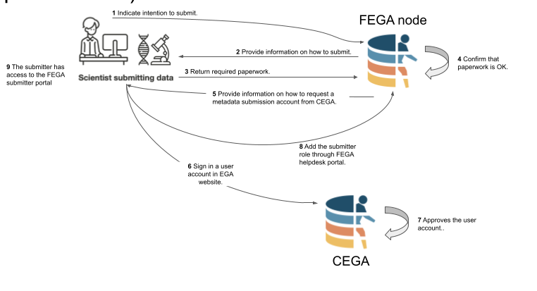

Email Template #1 - First set of information for new submitters

Subject: Guidance for submission to FEGA Portugal

Dear [Recipient Name],

Thank you for reaching out to our Helpdesk. We are happy to assist you in the process of uploading data into FEGA Portugal. To get started smoothly, please help us with the following details:

1. Legal and Ethical Compliance:

Start by contacting your institution’s Data Protection Officer (DPO).
Ensure you have ethical committee approval documents ready for submission.
Completing the Data Processing Agreement (DPA) (LINK) with the FEGA Portugal node is required.

While the DPO deals with the legal tasks, we can advance the more technical aspects:

2. Data Information:

Could you confirm the file types you'll be submitting (e.g., FASTQ, BAM, VCF) and an estimate of your total data volume (in GB or TB)?

3. Technical Capabilities:

Do you or your team have experience using the Terminal or command-line interfaces?
Is there a bioinformatician or IT specialist available to assist with data uploads?

4. Metadata Requirements:

Please check what types of metadata you will require (LINK). This will include information about your samples, study details, file descriptions, and methodologies.

If you have any questions or need clarification at any point, feel free to get in touch. We're here to help you through each step of the process.
Thank you, and looking forward to your reply!

Warm regards,
[Your Name]
[Helpdesk Team]
[Contact Information]

Email Template #2
Subject: Register in EGA
Dear [Recipient Name],
Thank you for providing your documentation. We are glad to inform you that the DPA was approved and we can now move on with the next phase of the submission.

In case you are not yet registered in EGA, please do so at (https://ega-archive.org/register/) so that you can proceed with the upload of the metadata of the submission

If you are already registered, please inform us of your registration email address, for FEGA Portugal to add you as a submitter.
In case you don’t remember the email, access https://profile.ega-archive.org/

Warm regards,
[Your Name]
[Helpdesk Team]
[Contact Information]

Email Template #3
Subject: Submitter role in EGA Portugal - Data Submission
Dear [Recipient Name],
We are glad to inform you that you have been assigned a submitter role in FEGA Portugal.
You can now start filling in the metadata and uploading your data for your submission. Please go to https://submission.portugal.ega-archive.org and follow the guidelines of the Submit Data Tutorial.
Please inform us after you have completed this task.
Warm regards,
[Your Name]
[Helpdesk Team]
[Contact Information]

